|  |  |
| --- | --- |
| **Name** | Umar Hayyat |
| **Roll No.** | 360 |

**Lab 7**

**Introduction to functions in Python**

**Objective:**

* Use of function to print factors of numbers between the given range.
* Use of function to return the value of (base)êxponent.

**Task 1:**

Implement the following function:

1. Factor (n) display all factors of number ‘n’ passed as parameter.
2. Display(start, end) this function takes the start and end of a range as parameter and call the above function factor ( ) to display the factor of all numbers in that range.

Now call the function display( ) in a program. Take the start and end of a range from the user pass it to the function to display the factor.

**Code:**

def factor(n):

for i in range(1,n):

if(n%i==0):

print(i)

def fact(start, end):

for j in range(start, end):

print("factor of", j)

factor(j)

a=int(input("please enter start point"))

b=int(input("please enter end point"))

fact(a, b)

**Output:**

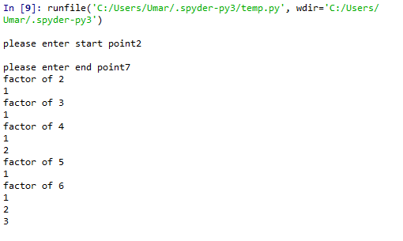

Figure no 7.1: Output of task 1

**Task 2:**

Write the output of following code fragment.

**Code:**

for x in range (11):

if(x%2==0):

print(x, end=' ')

else:

print(x)

**Output:**

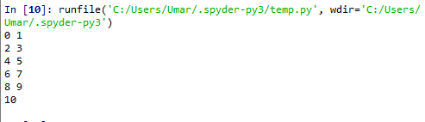

Figure no 7.2: Output of Task 2

**Task 3:**

Write a function integerPower(base, exponent) that return the value of

(base)êxponent

Assume that exponent is a positive, nonzero integer, and base is an integer.Take base and exponent values from the user, pass these values in the function and display the result.

**Note:** Neither use any library function nor exponential arithmetic operator.

**Code:**

def integerPower(base,exponent):

A=base

for num in range(1,exponent):

base=base*A

return base

base=int(input("Enter value of base "))

exponent=int(input("Enter value of exponent "))

x=integerPower(base,exponent)

print(x)

**Output:**

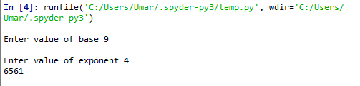

Figure no 7.3: Output of Task 3

**Task 4:**

Desired Output:

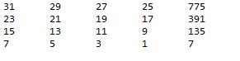

* Last column contain the multiplication result of 1st and 4th entity of corresponding row.

The code student wrote has been provided below:

i=31

while (i >=7):

j=i

while (j >= i-6):

print (j, end=’\t’)

j=j-2

m=i*j

print (m, end=’\n’)

i=i-8

Unfortunately, this code is unable to print desired output.

1. Write the exact output of student’s code.
2. Locate and correct the logical error in student code so that desired output can be achieved.

**Part(i):**

**Output:**

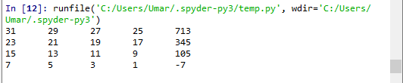

Figure no.7.4: Output of student code

**Part(ii):**

**Code:**

i=31

while (i>=7):

j=i

while (j>= i-6):

print (j,end='\t')

j=j-2

m=i*(j+2)

print (m,end='\n')

i=i-8

**Output:**

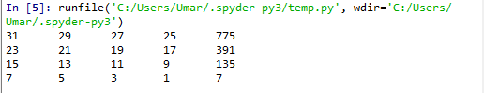

Figure no 7.5: Output of corrected student’s code

**Conclusion:**

I have learnt how to print factor of any integer by using function. I have learnt how to write the code of given output. I have learnt how to correct the given code.